Insurance Claims AI Assistant

Testing & Validation Report

1. Introduction
The Insurance Claims AI Assistant is an AI-powered analytics system that enables users to query an insurance claims dataset using natural language. The system uses a Retrieval-Augmented Generation (RAG) approach, where a Large Language Model (LLM) converts natural language queries into SQL queries. These queries are executed on a SQLite database, and the results are presented through a Streamlit web interface along with explanations and visualizations.
The purpose of this testing phase is to validate that:
- The system correctly converts natural language queries into SQL queries.
- The SQL queries retrieve accurate data from the database.
- The generated explanations are clear and relevant.
- The Streamlit application works without errors during real-world usage.
The system was tested using the nine sample questions provided in the assignment, along with additional edge cases to ensure robustness.

2. Testing Methodology
The testing process consisted of the following steps:
- Enter a natural language query in the Streamlit application.
- Verify that the AI model generates a valid SQL query.
- Execute the SQL query on the SQLite database.
- Validate that the retrieved results are accurate.
- Review the explanation generated by the AI model.
- Verify that the Streamlit application displays the results and charts correctly.
- Test edge cases such as invalid queries, missing values, and multi-metric queries.
Each query was evaluated based on:
- SQL correctness
- Data accuracy
- Explanation clarity
- Application stability

3. Sample Query Testing

Query 1

Question
Which city/state has the highest loss? Average loss? No. of claims?

SQL Logic

SELECT "City", "State", SUM("Repair Estimate Cost" + IFNULL("Hospital Cost", 0)) AS "Total Loss", AVG("Repair Estimate Cost" + IFNULL("Hospital Cost", 0)) AS "Average Loss", COUNT(*) AS "Number of Claims" FROM claims GROUP BY "City", "State" ORDER BY "Total Loss" DESC LIMIT 1;
The query groups claims by City and State, calculates total loss using repair estimate cost and hospital cost, and returns the location with the highest total loss.

Validation Result
The system correctly generated SQL with GROUP BY and ORDER BY clauses and returned the location with the highest total loss along with average loss and claim count.

Example Result
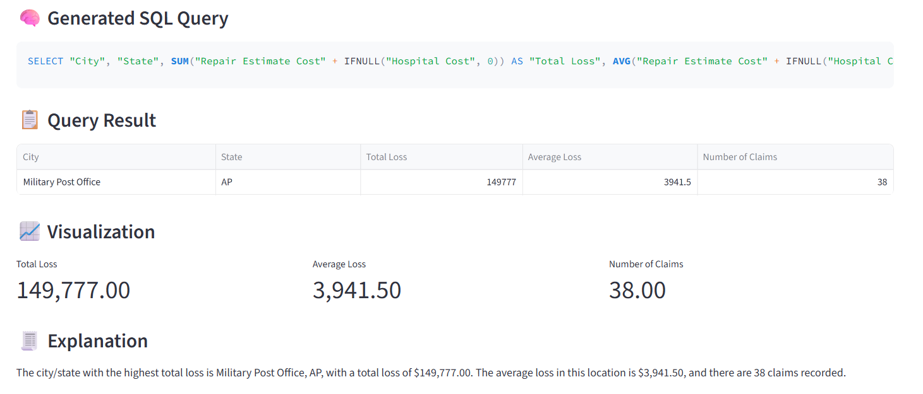

Query 2

Question
How many claims are under investigation? How many are completed?

SQL Logic

SELECT

SUM(CASE WHEN "Claim Status" = 'Under Investigation' THEN 1 ELSE 0 END) AS "Under Investigation Claims",

SUM(CASE WHEN "Claim Status" = 'Closed' THEN 1 ELSE 0 END) AS "Completed Claims"

FROM claims;
The query uses conditional aggregation to count claims based on claim status.

Validation Result
The model correctly generated a query using CASE WHEN conditions to calculate both metrics in a single SQL statement.

Example Result
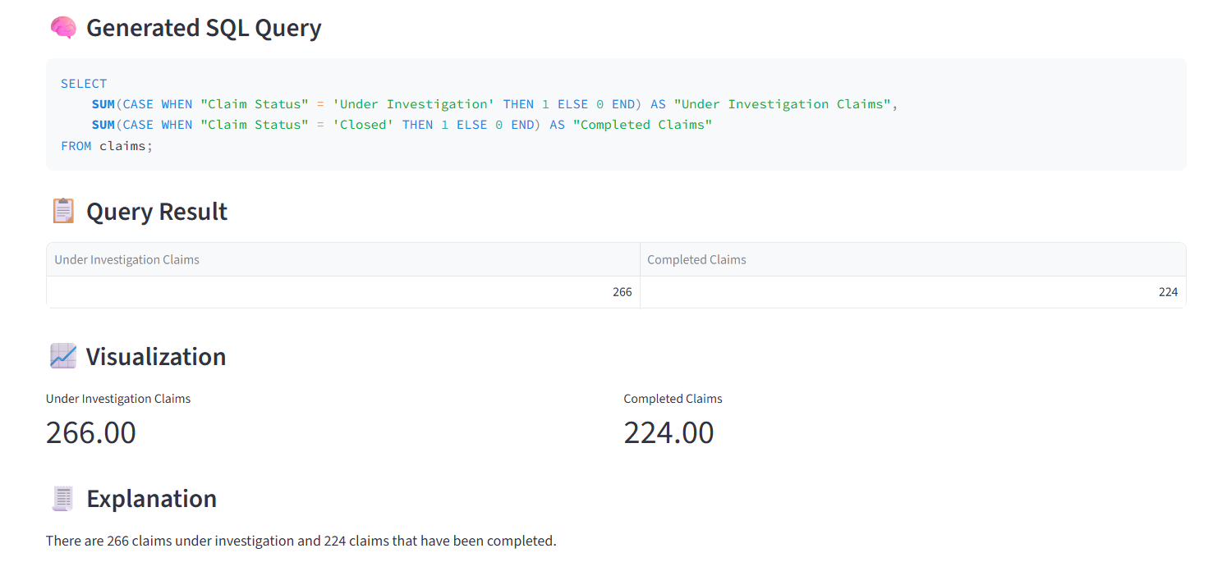

Query 3

Question
Which vehicle make and model is most prone to damage?

SQL Logic

SELECT "Vehicle Make", "Vehicle Model", COUNT(*) AS "Damage Count" FROM claims GROUP BY "Vehicle Make", "Vehicle Model" ORDER BY "Damage Count" DESC LIMIT 1;
The query groups data by vehicle make and vehicle model and counts the number of claims for each combination.

Validation Result
The system correctly identified the vehicle make and model with the highest number of claims.

Example Result
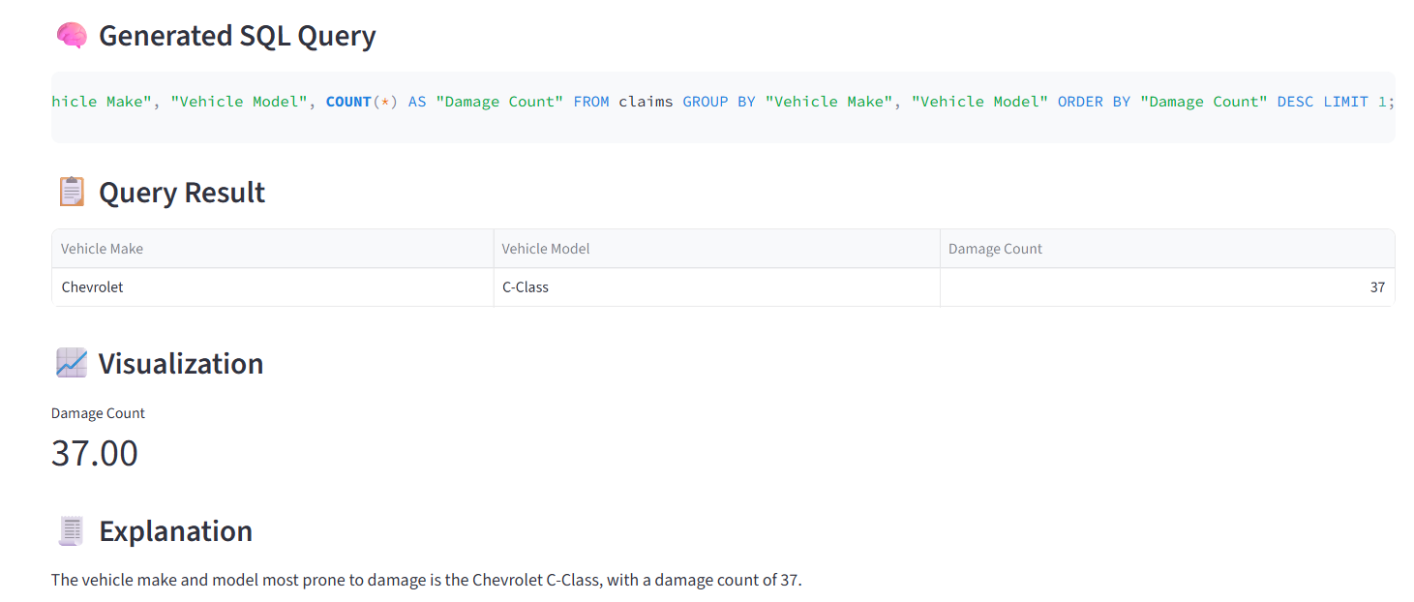

Query 4

Question
For the claims received, how many percent required hospitalization?

SQL Logic

SELECT (SUM(CASE WHEN "Hospital Records" IS NOT NULL THEN 1 ELSE 0 END) * 100.0 / COUNT(*)) AS "Percent Required Hospitalization" FROM claims;
The query calculates the percentage of claims where medical injury documentation is marked as "YES".

Validation Result
The SQL query correctly calculated the percentage using COUNT and conditional filtering.

Example Result

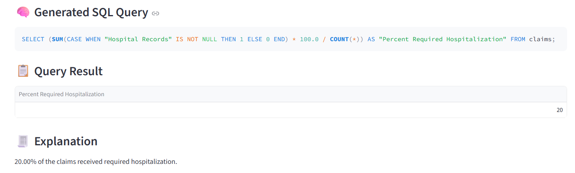

Query 5

Question
What was the average repair estimated cost?

SQL Logic

SELECT AVG("Repair Estimate Cost") FROM claims;
The query calculates the average of the Repair Estimate Cost column.

Validation Result
The system correctly generated a query using the AVG function and returned the average repair estimate cost.

Example Result

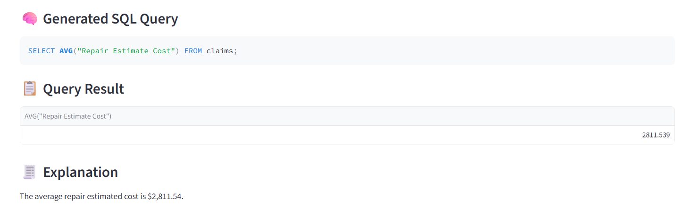

Query 6

Question
For the new claim received (damage: side collision) what would be the average repair cost?

SQL Logic

SELECT AVG("Repair Estimate Cost") FROM claims WHERE "Claim Status" = 'Open' AND "Damage Description" = 'Side collision';
The query filters claims where the damage description contains "Side Collision" and calculates the average repair estimate cost.

Validation Result
The result provides an estimate based on historical side collision cases.

Example Result
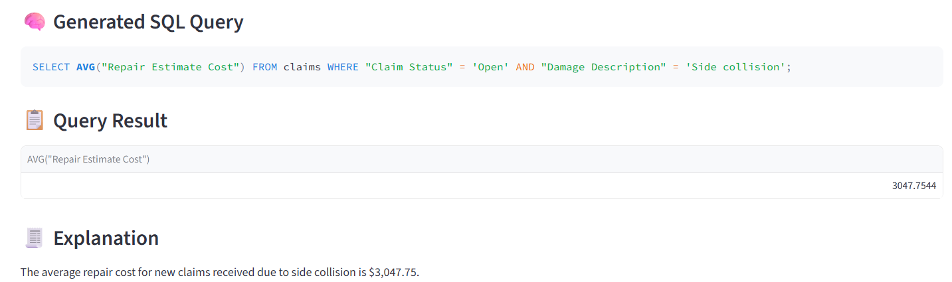

Query 7

Question
Average cost of physiotherapy required?

SQL Logic

SELECT AVG("Hospital Cost") FROM claims WHERE "Hospital Records" = 'Physiotherapy';
The query filters claims where hospital records indicate physiotherapy and calculates the average hospital cost.

Validation Result
The system correctly identified physiotherapy cases and computed the average treatment cost.

Example Result
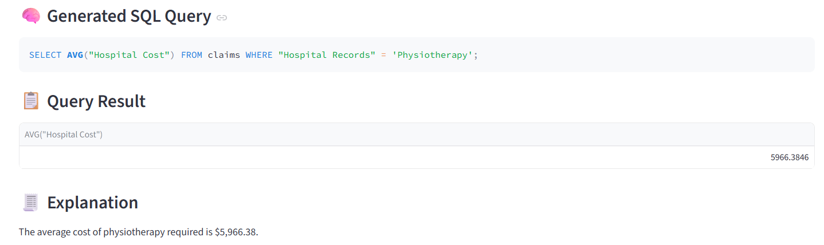

Query 8

Question
For a fractured arm, what is the ballpark number for hospitalization? Max and minimum?

SQL Logic

SELECT MAX("Hospital Cost"), MIN("Hospital Cost") FROM claims WHERE "Medical Reports" = 'Fractured arm';
The query calculates the maximum and minimum hospital cost values for fracture-related cases.

Validation Result
The system correctly returned the highest and lowest hospitalization costs.

Example Result
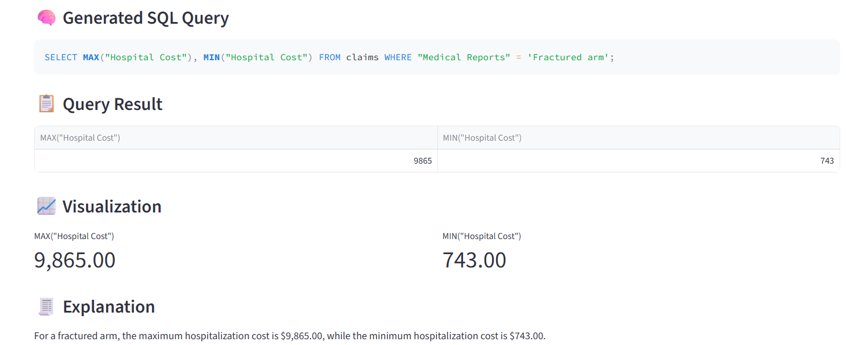

Query 9

Question
How many claims required hospitalization? How much percent of them were severe?

SQL Logic

SELECT COUNT(*) AS "Total Claims Requiring Hospitalization",

SUM(CASE WHEN "Hospital Records" IN ('Surgery required', 'ER visit (emergency treatment)') THEN 1 ELSE 0 END) AS "Severe Claims",

(SUM(CASE WHEN "Hospital Records" IN ('Surgery required', 'ER visit (emergency treatment)') THEN 1 ELSE 0 END) * 100.0 / COUNT(*)) AS "Percentage of Severe Claims"

FROM claims

WHERE "Hospital Records" IS NOT NULL;
The query counts claims with hospitalization and calculates the percentage of severe cases using conditional aggregation.

Validation Result
The system correctly calculated the total number of hospitalization claims and the percentage of severe cases.

Example Result
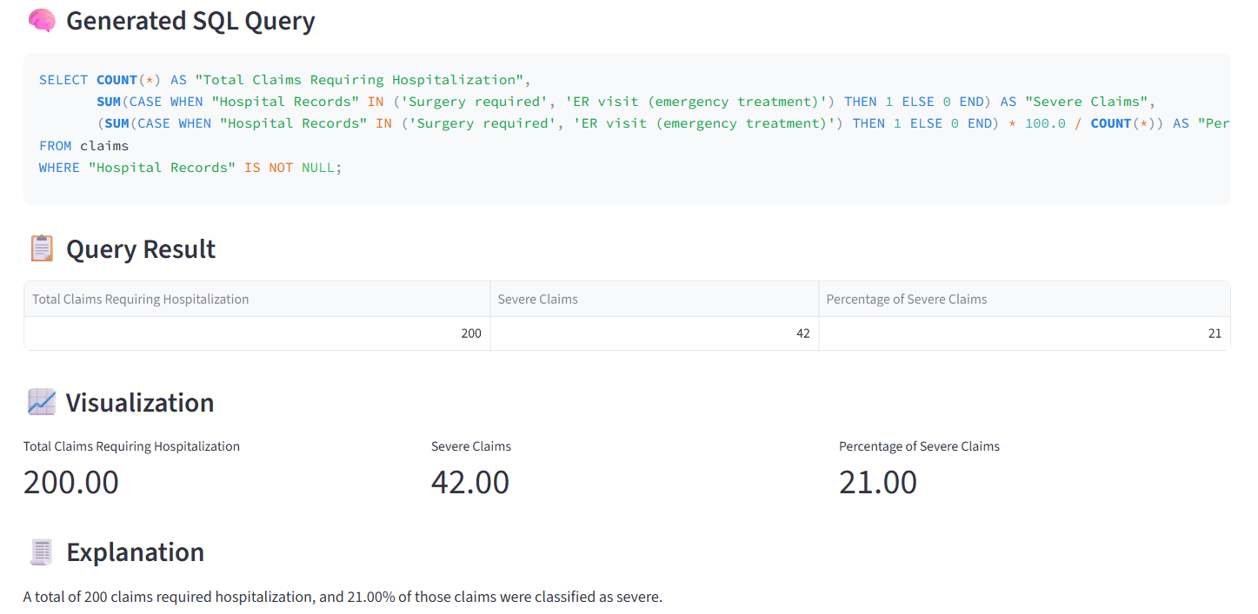

4. Edge Cases and Errors Encountered
During testing, several edge cases and potential errors were identified and addressed.

Multiple Metrics in One Query
When a user asked for multiple metrics in a single query, the LLM initially generated multiple SQL statements. Since the system expects a single SQL query, this caused execution errors.

Solution
The prompt was updated to enforce conditional aggregation using CASE WHEN so that all metrics are returned in a single query.

- SQL Returned with Markdown Formatting
Sometimes the AI model returned SQL queries inside markdown blocks.
Example:
```sql
SELECT ...
This caused execution errors.
### Solution
A SQL cleaning function was implemented to remove markdown formatting before executing the query.
- Incorrect Column Selection by LLM
In some cases, the LLM selected incorrect columns due to ambiguous descriptions.
### Solution
Schema descriptions were improved to include detailed explanations of each column and its possible values.
- Empty Query Input
If the user clicked the Run Query button without entering a question, the system attempted to generate SQL.
### Solution
Input validation was added to display a warning message.

- Queries Returning No Results
Some queries returned empty datasets.
### Solution
The application now displays a user-friendly message:

No results found.
- LLM Variability

The LLM sometimes generated slightly different SQL queries for the same question.

### Solution
The temperature parameter was set to zero to ensure consistent SQL generation.

- Streamlit Application Validation

The Streamlit application was tested to verify that all required features work correctly.

  - Natural language query input
  - SQL generation
  - Database retrieval
  - Result table display
  - Chart visualization
  - Explanation generation
  - Error handling

Charts were automatically generated when the result contained numeric data suitable for visualization.

Conclusion

The testing results demonstrate that the Insurance Claims AI Assistant successfully converts natural language questions into SQL queries and retrieves accurate results from the database.

